Karen A. O’Donnell is currently serving as the President of the Colorado Parks & Recreation Association’s Executive Board. She is employed by The City of Commerce City as the Recreation Division Manager. Karen received a BS in Therapeutic Recreation from Ohio University, and a Master of Public Administration in Health Services Management from Mercy College. She started her career at a recreation therapist, working with adolescent males with severe emotional and behavioral disorders in Yonkers, New York, before moving into the municipal parks & recreation field, which is her passion. Originally from Cleveland, OH, Karen is an avid Cleveland Browns & Cleveland Indians fan. She also enjoys traveling the world, aerial yoga, and spending time with her beautiful lab mix, Mojo.
email: KOdonnell@c3gov.com

Emily Patterson is the Program Director for The Trust for Public Land. Emily has 15 years of experience working with communities and local, state, and federal partners to protect, plan, design, and build public spaces. She has been with The Trust for Public Land since 2012. The Colorado Parks for People Program currently includes park renovation and new park construction projects across the Denver Metro Area and in Colorado Springs. Emily earned a BA in Anthropology and a Master of Landscape Architecture from the University of Georgia. email: Emily.Patterson@tpl.org

Bob Tipton is a high-energy, innovative, and insightful transformational change architect, leadership facilitator, keynote speaker, and author who is passionate about helping individuals, groups and entire organizations reach for and achieve exceptional results. Specializing in five primary industries: government, utilities, education, healthcare, and non-profits, Bob’s key strengths are in vision casting, disruptive strategies, cultural assessments, organizational coaching, innovation, and team dynamics. email: Bob@RSTipton.com

Debra Walsh, LCSW is the Social Work Coordinator for Jefferson County Public Library. Her role includes connecting patrons to community resources; providing training for staff on issues related to homelessness, trauma-informed care, mental health and substance misuse, among other topics; and providing guidance for the library system on meeting the needs of the community. Her background is in community mental health and she had worked as a psychiatric social worker prior to coming to the library. She received her Master of Social Work from the University of Illinois. email: Debra.Walsh@JeffcoLibrary.org

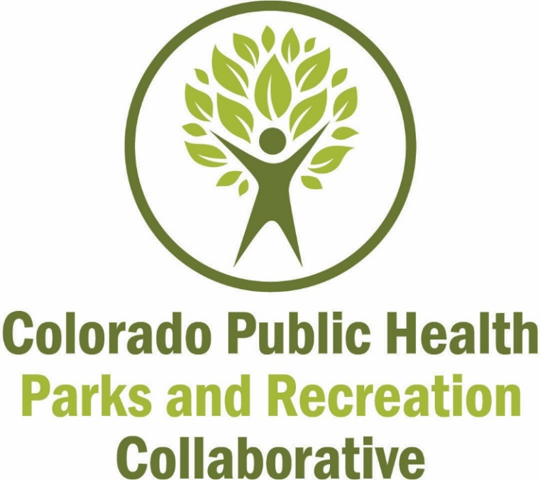

Speaker Biographies

Annual Summit
For the Sake of Healthy Places and Community Spaces
March 8, 2019
Westminster, CO

Chandi Aldena is the Project Manager of the Colorado Parks for People Program at The Trust for Public Land. Raised in Denver, CO, Chandi learned to love the great outdoors at a young age; she spent her summers outdoors playing in city parks and camping in the Rocky Mountains with her family. Her love of nature and interest in design led her to pursue a career in the environmental field and she received a BS in Landscape Architecture from CSU and a Master of Landscape Architecture from UC Denver. Her enthusiasm for park design and community engagement brought her to The Trust for Public Land in 2014 where she uses her expertise in participatory design to engage communities in hands-on workshops to create the vision and design for their neighborhood park. email: Chandi.Aldena@tpl.org

Nick Bohnenkamp is a deep listener, thoughtful questioner, and pragmatic decision maker. He loves to help organizations of all types – nonprofit, government, for profit – do good while doing good. Nick believes in evidence-based decision making, positive feedback loops, and that the foundation of a company’s culture is built through small, quality interactions among employees and between the clients they serve. Nick’s key strengths are in business operations and continuous improvement, specifically applied to operational units of government.
email: Nick.Bohnenkamp@RSTipton.com

Kim Boyd is currently the President of Lolina, Inc., a consultancy with clients in the healthcare, human services and the public health arena. Kim has been involved in healthcare and public health for over 22 years as a Registered Nurse and Nurse Practitioner. Kim has a particular passion for health policy and supporting systems that aim to improve that health of our Colorado communities. Kim is the President-Elect of Colorado Public Health Association and coordinates the Colorado Public Health Mentoring Program. Kim earned her MS/Women’s Health Care Nurse Practitioner and Doctor of Nursing degree from the University of Colorado. Kim is certified as a Gallup Strengths Coach, certified in EQ-i Emotional Intelligence and completing certification as a Certified Professional Co-Active Coach. She volunteers as a peer coach for the Regional Institute of Health and Environmental Leadership (RIHEL). email: Kim@lolina-health.com

Cindy Campbell is the Executive Director and founder of Washington Underground Recreation Center and Director of LiveWell Huerfano County, a nonprofit dedicated to increasing healthy eating and active living. She is a Certified Public Accountant with an MA in Business Administration from CU Boulder and a M Ed. from University of Phoenix. She is a director on Huerfano Parks and Recreation District Board and La Veta Trails Board. email: CCampbell@sprhc.org

Kevin Colón serves a non-profit called GlocalNet whose purpose is to relentlessly pursue peace and reconciliation among all peoples in all places for all things. Kevin serves GlocalNet in many ways primarily focusing on facilitating multi-faith, bridge-building retreats for Christian, Jewish and Muslim religious leaders. Kevin earned a degree in Religious Studies from Western Kentucky University and a Master of Divinity from Southwestern Seminary. His career has included various community building roles including lead pastor, church planter and consultant. Kevin also works part time in volunteerism and student leadership as a part of the Parks, Recreation and Open Space Department for the Town of Superior. Giving back is important to Kevin and his family. They have been heavily involved humanitarian efforts in Vietnam over the last 20 years. Kevin resides in Superior, CO with his wife Amy and their four daughters. email: KC@kevincolon.com | twitter: @colonkevin

Sister Pat Hayden, SC serves as the Vice President of Mission Integration and Community Relations at St. Anthony North Health Campus. She is a certified chaplain and holds a BA in Education and an MA in Adult Christian Community Development. Sister Pat has been with St. Anthony North for 27 years. She serves on the Board of the Metro North Chamber of Commerce (MNCC) and the St. Anthony Health Foundation. Recently she was awarded the 2018 Community Impact Award from the Women of the Metro North, a group sponsored by MNCC and the Colorado Women’s Chamber of Commerce. email: PatriciaHayden@Centura.Org
Eugene D. Howard is a husband, father of two, and Planner with the City and County of Denver. He loves working in and with communities to bring their needs and aspirations to the attention of others through the planning process. Eugene “discovered” the planning profession volunteering on the board of his registered neighborhood organization, representing his community through various city-led plans for Northwest Denver. Eugene has a fondness for multimodal and active transportation having lived in major cities on both coasts where he found the beauty of the built environment by traveling without his car. He values giving back to community through participating on numerous boards and associations, charitable giving, and by teaching future city planners as an adjunct lecturer at his graduate alma mater, UC Denver. email: Eugene.Howard@denvergov.org

Robby Layton is a founding principal of award-winning landscape architecture and planning firm Design Concepts, CLA, Inc. His work spans four decades and addresses a wide range of challenges, all of which converge on the theme of creating community. His research work has focused on strategic planning for systems of parks, greenways, open space and other public amenities, with a focus on greenspace as a public health intervention. He is currently a Teaching Assistant Professor in Landscape Architecture at North Carolina State University’s College of Design and an Affiliate instructor at Metropolitan State University of Denver, and serves on the Operation Board of GP RED, a nonprofit organization dedicated to translating research into practice for the purpose of building better communities.
email: RobbyL@DCLA.net

